**1). Write a C program to read no 1 to 7 and print relatively day Sunday to Saturday.**

**CODE 1 :**

/*Write a C program to read no 1 to 7 and print relatively day Sunday to Saturday*/

#include<stdio.h>

int main()

{

int a, b;

printf("Enter Any Number Between 1 to 7.\n");

scanf("%d", &a);

switch (a)

{

case 1:

printf("Today Is Sunday");

break;

case 2:

printf("Today Is Monday");

break;

case 3:

printf("Today Is Tuesday");

break;

case 4:

printf("Today Is Wednesday");

break;

case 5:

printf("Today Is Thursday");

break;

case 6:

printf("Today Is Friday");

break;

case 7:

printf("Today Is Saturday");

break;

default:

printf("Please Enter The Valid Number");

break;

}

return 0;

}

**OUTPUT 1 :**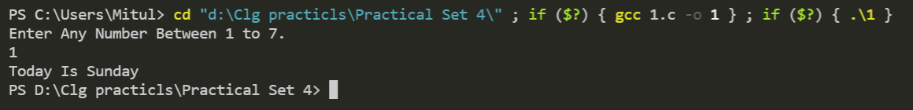

**2) Write a program to find roots of a quadratic equation.**

**CODE 2 :**

/*Write a program to find roots of a quadratic equation.*/

#include <math.h>

#include <stdio.h>

int main()

{

double a, b, c, discriminant, root1, root2, realPart, imagPart;

printf("Enter coefficients a, b and c: ");

scanf("%lf %lf %lf", &a, &b, &c);

discriminant = b * b - 4 * a * c;

// condition for real and different roots

If (discriminant > 0)

{

root1 = (-b + sqrt(discriminant)) / (2 * a);

root2 = (-b - sqrt(discriminant)) / (2 * a);

printf("root1 = %.2lf and root2 = %.2lf", root1, root2);

}

// condition for real and equal roots

else if (discriminant == 0)

{

root1 = root2 = -b / (2 * a);

printf("root1 = root2 = %.2lf;", root1);

}

// if roots are not real

else

{

realPart = -b / (2 * a);

imagPart = sqrt(-discriminant) / (2 * a);

printf("root1 = %.2lf+%.2lfi and root2 = %.2f-%.2fi", realPart, imagPart, realPart, imagPart);

}

return 0;

}

**OUTPUT 2 :**

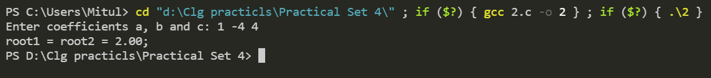

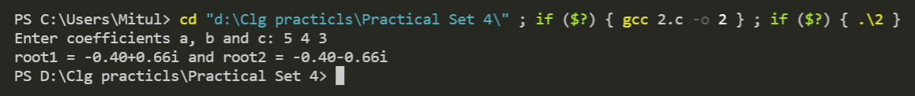

**3). Write a program to read a four digit integer and print the sum of its digits.**

**CODE 3 :**

/*Write a program to read a four-digit integer and print the

sum of its digits.*/

#include <stdio.h>

#include <conio.h>

Int main()

{

int num, reminder, sum = 0;

printf("Enter A Four Digit Integer : ");

scanf("%4d", &num);

while (num > 0)

{

reminder = num % 10;

sum = sum + reminder;

num = num / 10;

}

printf("The Sum Of The Digits Of Entered Number Is %d", sum);

return 0;

}

**OUTPUT 3 :**

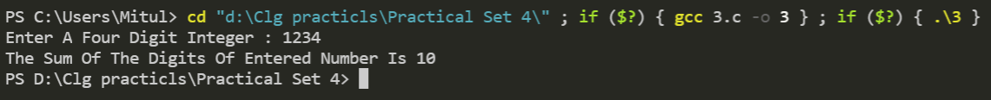

**4). Write a program to read two numbers m and n and to decide and print whether m is a multiple of n.**

**CODE 4 :**

/*Write a program to read two numbers m and n and to

decide and print whether m is a multiple of n.*/

#include <stdio.h>

#include <conio.h>

int main()

{

int m, n;

printf("Enter Values Of M And N : \n");

scanf("%d %d", &m, &n);

printf("The Value Of M=%d And N=%d.\n", m, n);

If (m % n == 0)

{

printf("M Is Multiple Of N.");

}

else

printf("M Is Not Multiple Of N.");

return 0;

}

**OUTPUT 4 :**

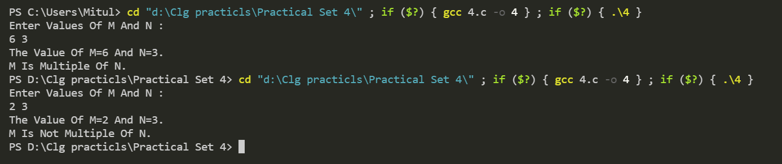

**5). Write a program to read marks of a student from keyboard whether the student is pass or fail( using if else).**

**CODE 4 :**

/*Write a program to read marks of a student from keyboard

whether the student is pass or fail( using if else)*/

#include <stdio.h>

int main()

{

int marks;

printf("Enter The Marks Out Of 100 :");

scanf("%d", &marks);

if (marks >= 33)

printf("PASS");

else

printf("FAIL");

return 0;

}

**OUTPUT 5 :**

